

SENG3210 Applied Software Engineering

Lab 05

Module: Unit Testing in Android Studio

Task 1: Creating a Test Plan
Test Plan
1. Overview
- Method Name: ABS
- Description: Takes an input and calculates absolute value.
- Expected Behavior: Takes an input and calculates absolute value.
2. Test Cases
TC-01 | User inputs positive number. | +int | +int | Normal function
TC-02 | User inputs negative number. | -int | +int | Normal function
TC-03 | User inputs string. | string | Error code | Throws custom error.

Task 2: Create Test for the MathUtil class.

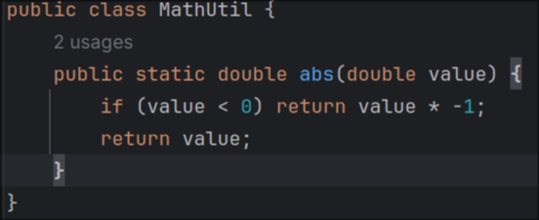

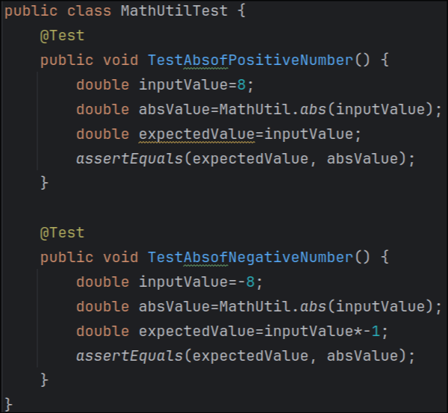

Task 3: Practice more tests

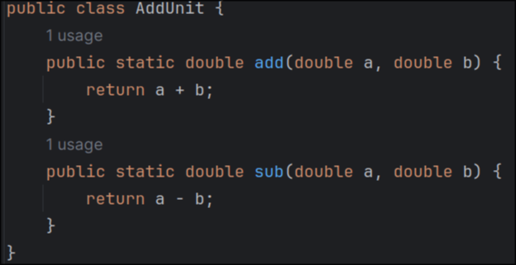

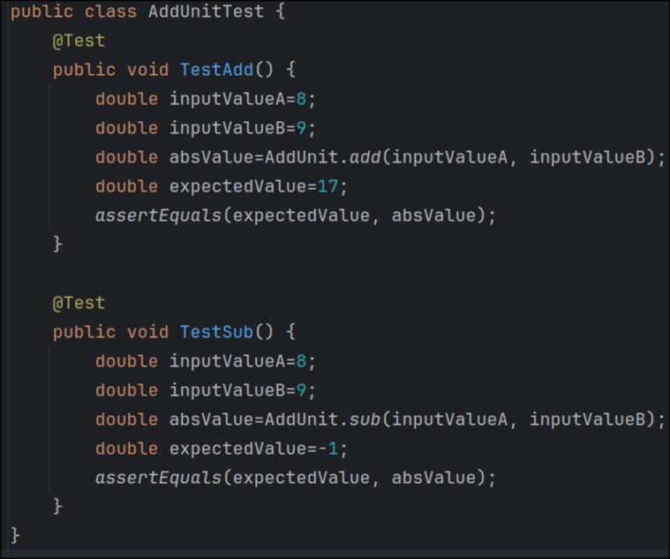



Reflection
The testing was a bit too easy, but its nice to know how it works.

